Making Hospital Care Better for People with a Learning Disability
NCEPOD is a charity which works to make healthcare services better for the people who use them.
Our work has led to good changes in how healthcare is provided. We are trying to make hospital admissions for people with a learning disability better.
What is this study about?
We are collecting information to see how care can be improved in the future for people with a learning disability who stay in a hospital when they are unwell.
The study will be used to produce a report for clinicians and other healthcare professionals about how to improve the care they deliver.
Information is being collected across England, Wales, Northern Ireland and Jersey.
Who should complete this questionnaire?
People who care for a person(s) with a learning disability
Your information is private
All responses given as part of this study are confidential. We remove all personal details, so no one will know who you are.
Privacy notice - https://shorturl.at/Jucy4
Want a copy of the report?
Email: learning@ncepod.org.uk
How to return this survey to NCEPOD
📧 via Email: learning@ncepod.org.uk
📧 via Post: RTBS-XCXG-RGLA, NCEPOD, Ground Floor, Abbey House, 74-76 St John Street, London, EC1M 4DZ (This is a free post address)
Need help?
📞 Call: 0207 251 9060
Section A. Patient and carer information

- Are you a carer for someone with a learning disability?
[ ] Yes
[ ] No – Please do not complete this survey

- Is the person you care for aged 18 or older?
This survey is about adults aged 18 and above
[ ] Yes
[ ] No – Please do not complete this survey

- What is your relationship to the person you care for?
Please tick all that apply
[ ] Family member
[ ] Partner/ spouse
[ ] Friend
[ ] Paid carer
[ ] Prefer not to say
[ ] Other – please give details

- During the time you have been a carer for them, has the person you care for ever been admitted to hospital?
[ ] Yes
[ ] No – Please do not complete this survey
[ ] Unsure/ Can’t remember

Section B. Learning disability awareness
If the person you care for has had multiple admissions to hospital, please answer the following questions in relation to the most recent admission
1. Did the hospital staff know that the person you care for had a learning disability when they got to hospital?
[ ] Yes
[ ] No – Go to section C
[ ] Unsure/ Can’t remember – Go to section C

2. If Yes, How did the hospital staff know that the person you care for has a learning disability?
Please tick all that apply
[ ] The person you care for told them
[ ] The hospital team could see it on the notes/ records
[ ] From their hospital passport
[ ] You told them
[ ] The person who sent them to hospital told them
[ ] They asked you if the person you care for has a learning disability
[ ] Unsure/ Can’t remember
[ ] Other – please give details

Section C. Hospital and carer passports
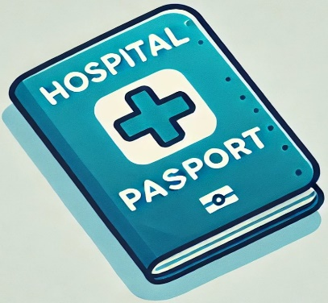
This is a form used to help hospital staff know more about your needs, and how to care and support you.

- Does the person you care for have a hospital passport?
[ ] Yes
[ ] No – Go to question 4
[ ] Unsure/ Can’t remember – Go to question 4

- If Yes, Was the person you care for asked to provide their hospital passport?
[ ] Yes
[ ] No – Go to question 4
[ ] Unsure/ Can’t remember - Go to question 4

- If Yes, Do you think the hospital passport was used?
[ ] Yes
[ ] No
[ ] Unsure/ Can’t remember

- Did the hospital have a carer passport or similar document?
This could give extra information on the help available to carers when the person they care for goes to hospital e.g parking, longer visiting hours
[ ] Yes
[ ] No – Go to question 6
[ ] Unsure/ Can’t remember – Go to question 6

- What is in your carer passport?
Please tick all that apply
[ ] Free parking
[ ] Refreshments provided
[ ] Meals provided
[ ] Open visiting hours
[ ] Staying 24/7
[ ] Fold up beds
[ ] Access to toilets on the ward
[ ] Unsure/ Can’t remember
[ ] Other – please give details

- If No to Q4, Would you find it helpful to have a carer passport?
[ ] Yes
[ ] No - – Go to section D

- If Yes, Which of the following would be helpful?
Please tick all that apply
[ ] Free parking
[ ] Refreshments provided
[ ] Meals provided
[ ] Open visiting hours
[ ] Staying 24/7
[ ] Fold up beds
[ ] Access to toilets on the ward
[ ] Unsure/ Can’t remember
[ ] Other – please give details

D. Carers helping you whilst in hospital
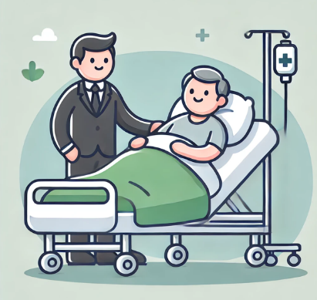

- Were you able to be with the person you care for as much as you wanted to/ needed to when they stayed in hospital?
[ ] Yes
[ ] No – Go to question 4
[ ] Unsure/ Can’t remember – Go to question 4

- If Yes, Do you feel it was helpful to be in hospital with them?
[ ] Yes
[ ] No – Go to question 4
[ ] Unsure/ Can’t remember – Go to question 4

- If Yes, what was helpful?
Please tick all that apply, then go to question 4
[ ] Sharing information about their health
[ ] Helping them make decisions about their health, such as having blood test
[ ] Helping them eat and drink
[ ] Helping them wash and get dressed
[ ] Unsure/ Can’t remember
[ ] Other – please give details

- Did the hospital learning disability team come to see the patient you care for/ talk to you during the hospital admission?
[ ] Yes
[ ] No - Go to question 6
[ ] Unsure/ Can’t remember - Go to question 6

- Do you think this was helpful to the person’s experience?
[ ] Yes
[ ] No - Go to question 6
[ ] Unsure/ Can’t remember - Go to question 6

- Did the hospital staff keep you up to date with what was happening whilst they were in hospital?
[ ] Yes
[ ] No
[ ] Unsure/ Can’t remember

- In your opinion, do you think your role as a carer was acknowledged by the hospital team?
[ ] Yes - Go to question 8
[ ] No - Go to question 8
[ ] Unsure/ Can’t remember - Go to section E

- Please explain why you answered this way:

E. Reasonable adjustments
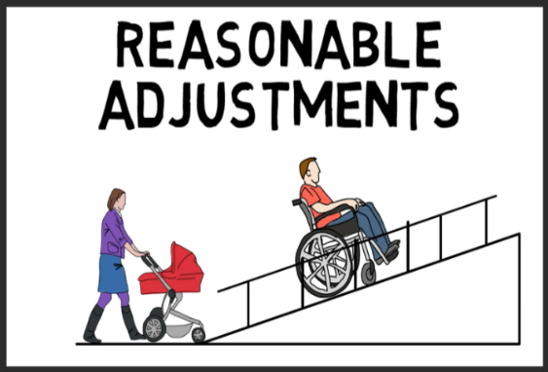
These are changes that can be made to support someone with a learning disability. These could include changes such as easy read information or allowing your carer to stay with you after visiting hours.
1. During their time in hospital, were any changes offered/ made to meet the needs of the person you care for?
[ ] Yes
[ ] No – Go to question 5
[ ] Not applicable – No changes needed – Go to question 5
[ ] Unsure/ Can’t remember – Go to question 5

2. If Yes, What changes were made for the person you care for?
Please tick all that apply
[ ] Time – Such as longer time with the nurse or doctor
[ ] Environment – Such as quieter room or ear defenders
[ ] Attitude – Such as your carer being able to stay outside visiting hours
[ ] Communication – Such as easy read leaflets; Talking Books/ Mats; British Sign Language; Makaton etc
[ ] Help – Such as including the learning disability team
[ ] Unsure/ Can’t remember
[ ] Other – please give details

3. If Yes, Were there any changes that were made which really helped?
[ ] Yes
[ ] No
[ ] Unsure/ Can’t remember
4. Please tell us more about this:

- Is there anything else that could have helped the person you cared for when they were in hospital?

F. Communication with hospital team

1. Did you the person you care for need help when making decisions about their health?
[ ] Yes
[ ] No
[ ] Unsure/ Can’t remember

2. Were you involved in the discussions and decisions about the health of the person you care for?
[ ] Yes
[ ] Yes – but not as much as I would have liked
[ ] No
[ ] Not applicable – not required
[ ] Unsure/ Can’t remember

G. After discharge from hospital

- When the person you care for left hospital, did you understand what had happened during the hospital stay?
[ ] Yes – Completely understand
[ ] Yes – Still had more questions
[ ] No
[ ] Not applicable – person died in hospital
[ ] Unsure/ Can’t remember

2. When the person you care for left hospital, did you know whether anything was planned next for their future care?
This could include any follow up appointments
[ ] Yes – Completely understand
[ ] Yes – Still had more questions
[ ] No
[ ] Not applicable – person died in hospital
[ ] Unsure/ Can’t remember

G. Overall comments

- Do you have any suggestions on how to improve care for people with a learning disability when they are in hospital?

- So we can share good ideas, please tell us what REALLY WORKS WELL when someone with a learning disability stays in hospital:

Do you have any suggestions for how we can make this survey better?

